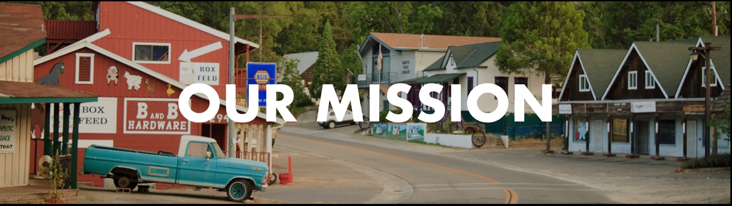
THE TITLE: We Are Called To Hospitality
THE PASSAGE: Acts 2:41-47
THE FOCUS: Colossians 3:12-17
THE POINT: Loving people is a powerful expression of loving God.
GOSPEL MISSION:
Empowering believers to live on mission, declaring the good news of the gospel in word and deed.

- GOSPEL WORDS
Acts 2:41-42
⁴¹ So those who received his word were baptized, and there were added that day about three thousand souls. ⁴² And they devoted themselves to the apostles' teaching and the fellowship, to the breaking of bread and the prayers.

- GOSPEL DEEDS
Acts 2:43-45
⁴³ And awe came upon every soul, and many wonders and signs were being done through the apostles. ⁴⁴ And all who believed were together and had all things in common. ⁴⁵ And they were selling their possessions and belongings and distributing the proceeds to all, as any had need.

3. GATHERED AND SCATTERED
Acts 2:46-47
⁴⁶ And day by day, attending the temple together and breaking bread in their homes, they received their food with glad and generous hearts, ⁴⁷ praising God and having favor with all the people. And the Lord added to their number day by day those who were being saved.

FAMILY QUESTIONS:
- What would living our lives like the church in Acts 2 look like today?
- How can helping people with everyday needs create opportunities to share your faith?
- The Bible says they had gladness and singleness of heart. Why is that significant in this passage?

HERE I AM TO WORSHIP
light of the world
You stepped down into darkness
opened my eyes, let me see
beauty that made this heart adore You
hope of a life spent with You

HERE I AM TO WORSHIP
HERE I AM TO BOW DOWN
HERE I AM TO SAY THAT YOU'RE MY GOD
YOU'RE ALTOGETHER LOVELY
ALTOGETHER WORTHY
ALTOGETHER WONDERFUL TO ME

King of all days
oh so highly exalted
glorious in heaven above
humbly you came to the earth You created
all for love's sake became poor

well, i'll never know how much it cost
to see my sin upon that cross

COME LORD JESUS
Jesus, we seek Your face
we seek Your face
come fill this place
when You come
everything
everything changes
nothing stays the same
darkness scatters
and the chain shatters
by the power of Your name
we want You to come, Jesus
WHOA-OA WHOA-OA-OA
OH-OH-OH
come, Lord Jesus
we long for You
come, Lord Jesus
do what You wanna do
come, Lord Jesus
we wanna see You
have Your way
in Your presence
the sick are healed
in Your presence
empty hearts are filled
in Your presence
the bound are free
in Your presence
there's victory
in Your presence
yokes are destroyed
in Your presence
there's fullness of joy
in Your presence
all that i desire
is to be consumed
with Your Holy Ghost fire

MIGHTY TO SAVE
well, everyone needs compassion
a love that's never failing
but let mercy fall on me

well everyone needs forgiveness
the kindness of a Savior
the hope of nations

MY SAVIOR
HE CAN MOVE THE MOUNTAINS
MY GOD IS MIGHTY TO SAVE
HE IS MIGHTY TO SAVE
FOREVER
AUTHOR OF SALVATION
HE ROSE AND CONQUERED THE GRAVE
JESUS CONQUERED THE GRAVE

so take me as you find me
all my fears and failures
and fill my life again
i give my life to follow
everything i believe in
and now i surrender
(i surrender)
shine your light and let the whole world see
we're singing for the glory of the risen King Jesus

YOU ARE GOD ALONE
You're not a God created by human hands
you're not a God dependent on any mortal man
you're not a God in need of
anything we can give
by Your plan, that's just the way it is
YOU ARE GOD ALONE, FROM BEFORE TIME BEGAN
YOU WERE ON YOUR THRONE, YOU ARE GOD ALONE
AND RIGHT NOW, IN THE GOOD TIMES AND BAD
YOU ARE ON YOUR THRONE, YOU ARE GOD ALONE

You're the only God whose power none can contend
You're the only whose name and
praise will never end
You're the only God who's worthy
of everything we can give
You are God, that's just the way it is

You're unchangeable, unshakable
unstoppable, that's who you are

HERE IN YOUR PRESENCE
found in your hands, fullness of joy
every fear, suddenly wiped away
here in your presence
all of my gains, now fade away
every crown, no longer on display
here in your presence

heaven is trembling in awe of your wonders
the kings and their kingdoms are standing amazed

HERE IN YOUR PRESENCE, WE ARE UNDONE
HERE IN YOUR PRESENCE, HEAVEN AND EARTH BECOME ONE
HERE IN YOUR PRESENCE, ALL THINGS ARE NEW
HERE IN YOUR PRESENCE, EVERYTHING BOWS BEFORE YOU

found in your hands, fullness of joy
every fear, suddenly wiped away
here in your presence
all of my gains, now fade away
every crown, no longer on display
here in your presence

wonderful, beautiful, glorious
matchless in every way

